Eagle Scout Award Dinner
San Diego and Imperial Counties
April 29, 2014
Gen JP Holland Chapter supports Eagle Scout at Annual Award Dinner. The Award Dinner was held at the ADM Kidd Club, near Point Loma. One Hundred and thirty six Eagle Scouts are honored. The MC was KFMB Conservative Morning Talk Show Host, Michael Slater. His wit and humor kept the night moving and enjoyeable.
The Guest Speaker, Aaron Linsdau, an Eagle Scout and adventurer provided a most exciting and informative story. The title of his talk was “Walk to Anartica.” Yes, Aaron walked from the beginning of the antartic ice shelf to the South Pole. You must imagine walking approimately 800 miles pulling everything you need to survive for several months. The weather conditions were worse than what you might think. Small physical problems become life threatning in the Antartic. Doing this alone makes the accomplshment of this feat even more amazing.
We can support the future Eagle Scouts next year, and send them to the Annual Awards Dinner. For a tax deductible $150 donation, you and a Eagle Scout will have a great dinner and receive a special pocket knife, engraved with the date and event on the blade.
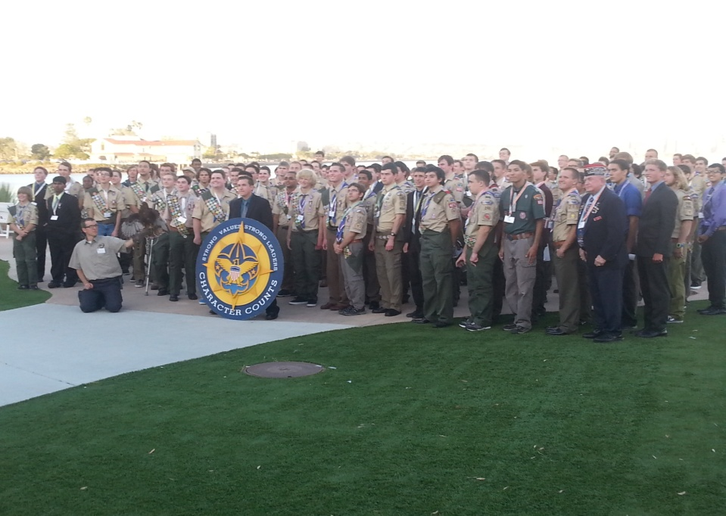 One hundred and thirty six Eagle Scouts and their sponsors pose for a photo behind the ADM Kidd Club.

